**ASSIGMENT 6.2**

PROBLEM STATEMENT:

1) Fetch date and temperature from temperature_data where zip code is greater than 300000 and less than 399999.

Query: select date, temperature from temperature_data where zip>300000 and zip<399999;

Output:

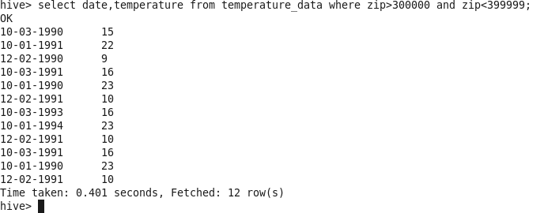

2) Calculate maximum temperature corresponding to every year from temperature_data table.

Query: select date, max(temperature) from temperature_data group by date;

Output:

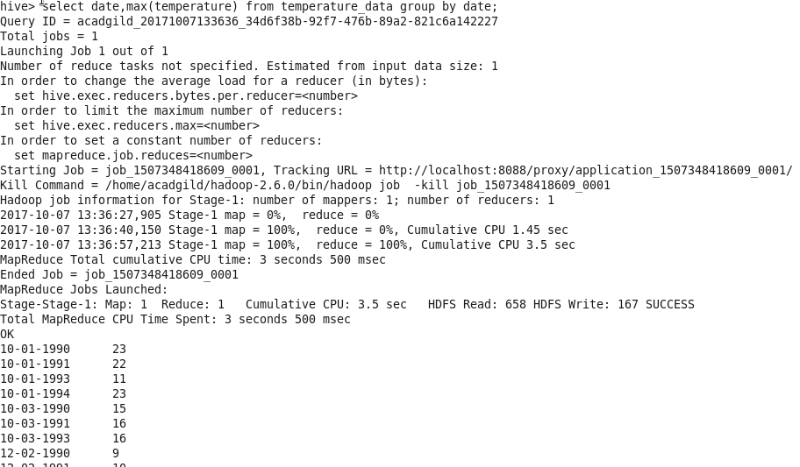

3)Calculate maximum temperature from temperature_data table corresponding to those years which have at least 2 entries in the table.

Query: select date,count(temperature),max(temperature) from temperature_data group by date having(count(temperature)=2).

Output:

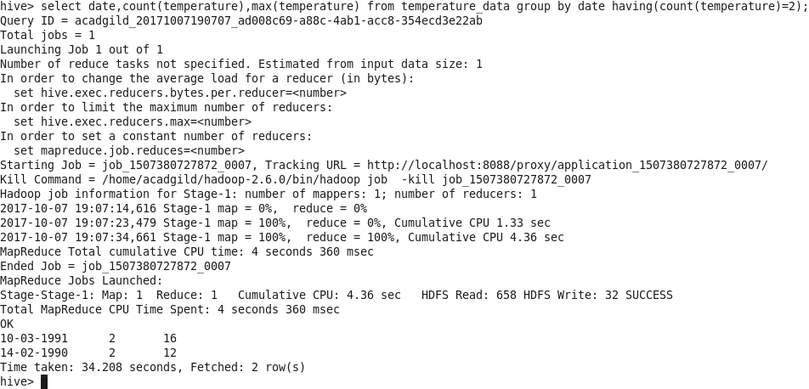

4) Create a view on the top of last query, name it temperature_data_vw.

Query: create view temperature_data_vw as select date,count(temperature), max(temperature) from temperature_data group by date having(count(temperature)=2);

select * from temperature_data_vw;

Output:

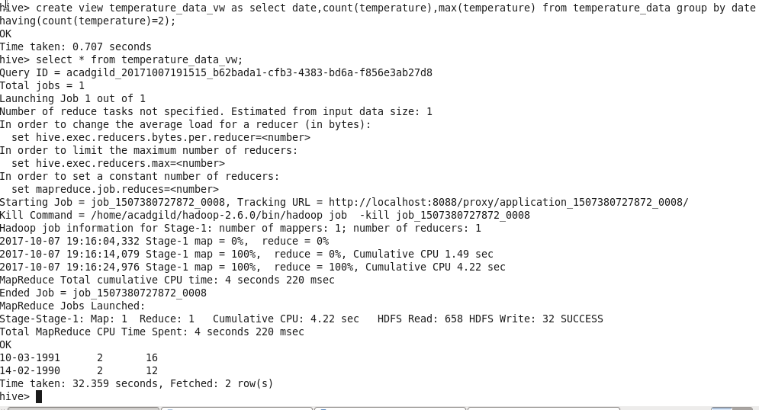

5) Export contents from temperature_data_vw to a file in local file system, such that each file is '|' delimited.

Query: Insert overwrite local directory ‘/tmp/ouput’

row format delimited

fields terminated by ‘|’

select * from temperature_data_vw;

Output:

